## Name:

## Partner:

## Section: 020_

# Lab 7 – OpAmp circuits

## Objectives

In this lab you will learn how to build and test simple circuits with an operational amplifier.

## Laboratory Equipment

ADALM2000, Breadboard, assorted resistors, LM741

## Pre-Lab

Draw a circuit diagram and a wiring diagram for an inverting OpAmp amplifier using LM741.

Wiring diagram includes DC power supplies, and show connections to the specific, numbered pins of the chip. Paste the drawing of the wiring diagram in the worksheet.

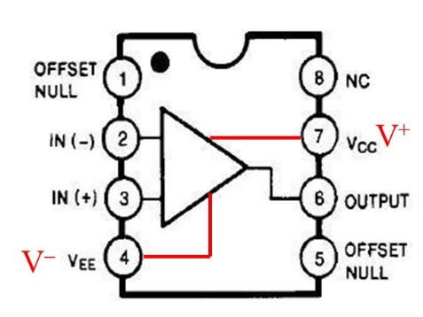

Pin diagram for LM741:

## Worksheet

*Follow the instructions below, type in answers in blue, and paste pictures in this document*

# Instructions

**I. Inverting amplifier**

1. Design and build inverting amplifier using LM741 with gain of -10 and input impedance of 1k Use the power supply on the ADALM2000 with +/- 5V for VCC and VEE.

R1:

R2:

1. Test with sine wave 1 kHz. Vary input amplitude from 100 mV to 10 Volts and record the input and output voltages (peak-peak) and calculate the gain.

|  |  |  |
| --- | --- | --- |
| V­s | Vout | Gain |
|  |  |  |
|  |  |  |
|  |  |  |
|  |  |  |
|  |  |  |
|  |  |  |
|  |  |  |

1. Briefly (2-3 sentences) explain the observed distortions (clipping) seen in part b.

**II. Summing amplifier**

1. Build a summing amplifier which produces output:

R1:

R2:

Rf:

1. Use signals from the two Waveform Generators with sine waves of equal amplitude, S1 with a frequency of 1 kHz and S2 with a frequency of 3 kHz. Observe and record the output , with phase of S2 equal to 0, 90 and 180 degrees. **Insert screenshots below:**

**III. Non-inverting amplifier**

1. Design and build a non-inverting amplifier with gain of approximately 10 (11 is ok) and minimum resistance of 1k

R1:

R2:

1. Measure and record the gain of this amplifier with sine wave with frequency of 1 kHz, 10 kHz and 100 kHz and a nominal amplitude of 200mV. Is this amplifier useful for audio frequency range?

|  |  |  |  |
| --- | --- | --- | --- |
| Frequency | V­s | Vout | Gain |
| 1kHz |  |  |  |
| 10kHz |  |  |  |
| 100kHz |  |  |  |

**IV. Post-lab Analysis**

1. Simulate the performance of the non-inverting amplifier from section III using CircuitLab or PSpice. Compare the experimental results with simulation.